Data Science: Machine Learning and Natural Language Processing

______________________________________________________________________________

Course Description:

Have you ever imagined how today’s Hedge Funds process textual based data in real-time to make trading decisions? How is it that online ads seem to show content related to things you like? In addition to learning research methodologies, this course deals with inferring human behavior and sentiment through two core aspects of Data Science: Machine Learning and Natural Language Processing.
______________________________________________________________________________

Goals:

- To gain a background in the basics of python, machine learning, natural language processing, and time series
- Complete a research assignment

Prerequisites: Students expected to have a basic understanding of mathematics and basic familiarity with the Python Programming Language. Please have the following installed on your laptops prior to the start of the first day of class:

- Install Python IDE – version 3.0
  - Anaconda distribution of Python

Individual Evaluations: Students will be evaluated based on the following criteria:

Class attendance consists of 10%
Homework 40%
Midterm 25%
Final Project 25%

______________________________________________________________________________

Course materials:

There is no specific textbook required. The professor will provide suggested books, papers and links for reference.

List of topics:

The topics covered will consist of the following:
Python
Machine Learning
Natural Language Processing
______________________________________________________________
Course Schedule:

Following is the tentative course schedule.
Lecture | HW | Topic(s)
1 |  | Course Introduction, Syntax, Variables, Operators, Regex, Datetime, Escape Characters, Functions
2 |  | Sets, Dictionary, Lists, For, While, Do, I/O Read/Write
3 | HW1 | Data Wrangling, Cleaning Data, Automation mind-set of modularity
4 | HW2 | Natural Language Processing: Text Tokenization, Stemming, Feature Matrix Manipulation  Topical Extraction: Naïve Approach
5 |  | Feature Selection: , TF, TF-IDF, Feature Vector, N-gram methods Data Summary: DataFrame Manipulation  Advanced Topical Extraction: LDA
6 |  | Feature Selection: Chi-Squared  Dimension Reduction: PCA  Advanced Transformers: Embeddings and LLMs
7 |  | Supervised Learning Algorithms: Random Forest, Naïve Bayes, SVM  Unsupervised Learning Classification: Clustering techniques  Prediction: Techniques and Model Metric (confusion matrix) comparison
8 | HW3 | Time Series Prediction: CNNs, Neural networks (RNNs, LSTMs, Transformers) for sequence modeling
9 | HW4 | Reinforcement learning for sequential decision making  Time Series: Random forests and gradient boosting for temporal data
10 |  | State space models with learnable components: neural Kalman filters and Variational Autoencoder for time series

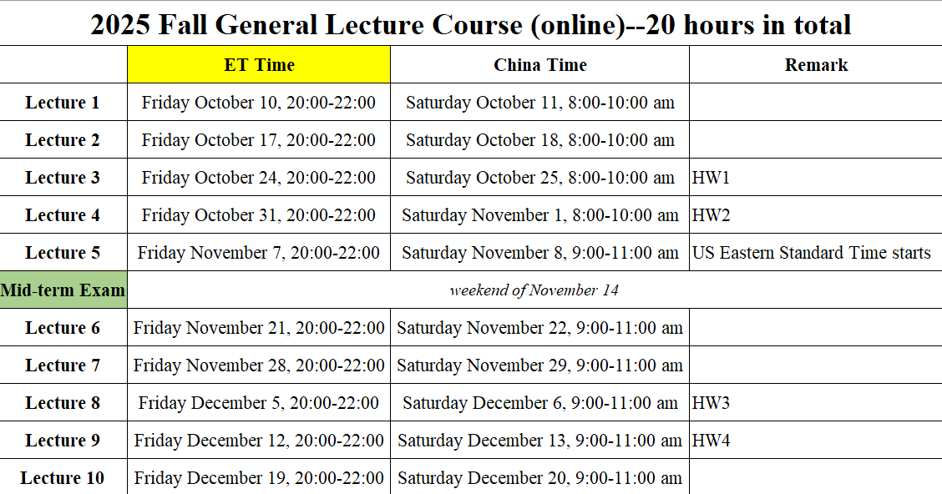
CIS – General Lecture Project

Objective:
In this project, you will employ Python programming to conduct an analysis of a text-based dataset using Natural Language Processing (NLP) techniques. You are required to prepare a report comprising 300-500 words alongside a Python script containing a minimum of 100 lines of code.

Assignment Description:

Dataset Selection:
Students are encouraged to select a text dataset that captures their interest. Below are some suggested datasets:
- Movie Reviews: A collection of movie reviews (e.g., IMDB, Rotten Tomatoes).
- Tweets: A set of tweets regarding a specific topic (e.g., political sentiment, public opinion on social issues).
- Product Reviews: Customer feedback data from e-commerce platforms like Amazon or eBay.
- News Articles: A collection of news articles on a particular subject (e.g., sports, politics, technology).
- Books or Articles: A dataset of books or articles suitable for analysis regarding topic modeling or keyword extraction.
Python Code Requirements:
- The analysis should consist of at least 100 lines of Python code.
- The code must encompass:
  - Text Preprocessing: Tokenization, removal of stopwords, stemming/lemmatization, and vectorization techniques such as TF-IDF or word embeddings.
  - NLP and/or ML Techniques: Implement NLP and/or ML algorithms.
  - Data Visualization: Illustrate the distribution of key terms or phrases.
  - Basic Evaluation: Assess model performance utilizing accuracy, precision, recall, or other pertinent metrics.

Written Report:

Word Count: 300-500 words
The report should include the following sections:
1. Introduction:
- Provide a brief introduction to the selected dataset and elucidate its relevance to your interests.
- Outline the problem being tackled using NLP, such as sentiment analysis or topic modeling.

2. Literature Review:
- Present a concise overview of existing research or methodologies associated with your analysis or general NLP tasks, exploring areas like:
  - The application of NLP in analyzing sentiment on social media.
  - Surveys of sentiment analysis methodologies employing machine learning.
  - Previous studies utilizing NLP in evaluating product reviews, movie critiques, or customer feedback.
  - Highlight common techniques or algorithms (e.g., Random Forest, Naive Bayes, SVM, or advanced deep learning models like BERT) employed in your analysis.
3. Methodology and Analysis:
- Detail the steps undertaken to analyze the dataset:
  - Text Preprocessing: What text-cleaning measures were implemented?
  - Modeling: Which model(s) did you select for data analysis? Offer insights into the construction of your machine learning model (e.g., feature engineering, algorithmic choice).
  - Discuss the outcomes of your analysis:
  - What trends were observed in the data?
  - What predictions did your model yield (e.g., sentiment classification)?
  - Did you uncover any noteworthy patterns or correlations in the textual data?
4. Research Proposal:
- Suggest potential avenues for future research or enhancements to your analysis:
- Is there a possibility to refine the model by integrating more sophisticated NLP techniques (e.g., transformer models like BERT)?
- Could additional features (e.g., user metadata) be incorporated to boost prediction accuracy?

Evaluation Criteria:
- (10%) Code Quality and Efficiency: The Python code should be well-written, clean, and efficient, with clear comments to explain each section.
- (10%) Text Preprocessing: The quality and thoroughness of your text preprocessing steps will be evaluated.
- (20%) Modeling and Analysis: How well you perform the analysis or other NLP tasks will be a key evaluation factor. This includes the appropriate choice of algorithm and the explanation of its use.
- (10%) Visualization: The visualizations should clearly convey the results of your analysis, whether that be i.e. sentiment distributions, word clouds, or feature importance.
- (50%) Written Report: The report should be well-structured, clear, and demonstrate a strong understanding of the task, literature, and findings.

Additional Guidelines:
- Dataset Size: The dataset should have at least a few thousand data points (e.g., tweets, reviews, articles) for meaningful analysis.
- Data Sources: Ensure the dataset is publicly available, and you clearly cite the source in the report.
- Ethical Considerations: When using social media or other publicly available datasets, ensure to respect user privacy and ethical guidelines

Example Topics:
- Sentiment Analysis of Movie Reviews:
Dataset: IMDB reviews or Rotten Tomatoes movie reviews.
Topic: Perform sentiment analysis on movie reviews to classify them as positive or negative and explore how sentiment correlates with movie success (box office performance).
- Analysis of Tweets on a Political Topic:
Dataset: A collection of tweets from Twitter about a political issue or candidate.
Topic: Analyze the topics of tweets and identify public opinion trends regarding a political event or figure.
- Product Review Sentiment Analysis:
Dataset: Product reviews from Amazon, eBay, or another e-commerce platform.
Topic: Analyze the sentiment of customer reviews to predict product success or identify areas for improvement.
- Topic Modeling in News Articles:
Dataset: A collection of news articles on various topics.
Topic: Perform topic modeling to identify key themes in news coverage or detect emerging trends in current events.

By the end of this project, students will have hands-on experience with NLP techniques and machine learning models and will gain insights into how these methods can be applied to real-world data. The project will also help students improve their ability to interpret and communicate their findings effectively through code and a written report.

Please submit the following:

A 300 - 500 word report in PDF format
At least 100 lines of Python code in .py format (.ipynb acceptable as well)

